Summer Student Project Report

Author: Mercedes Paniccia
September 13, 2002

1. Introduction

1.1 ATLAS Muon Spectrometer Detector Description Databases

The ATLAS offline software for the Muon Spectrometer [1] obtains detector description data from two ASCII databases: AMDB (ATLAS Muon Data Base ) [2] and AGDD (ATLAS Generic Detector Decription) [3]. AGDD is currently under development and evaluation as a possible replacement for AMDB [4]. I present here my work as part of that evaluation.
AMDB is a formatted ASCII file containing most of the basic parameters of the geometry, including the four subsystems (Monitored Drift Tube chambers, Cathode Strip Chambers, Resistive Plate Chambers and Thin Gap Chambers) and the inert matter (magnets, feet, support structure) [5], as well as some basic parameters describing other ATLAS detectors. The algorithms needed to interpret and translate the parameters into geometrical structures are embedded in the application programs. The AMDB database is currently used for the baseline reconstruction software (MuonBox) [6], the GEANT3 simulation software (DICE) [7], and the Persint [8] graphics package; it is parsed into data structures accessed by the offline software to feed applications based on the MuonDetDescr package, such as the MOORE [9] object-oriented reconstruction program and several of the ATLAS graphics programs. AMDB is also used for the GEANT4 [10] simulation of the Muon Spectrometer and is the basis for the detector description database currently in use by the GEANT4 simulation framework called FADS/GOOFY [11].
AGDD language was born in 1999, when the offline software and physics coordination decided that the detector description data for all ATLAS detectors should be provided in a standard format and input using common parsing software, independent of the application. XML (eXtensible Mark-up Language) [12] was selected as language base for developing AGDD, because of the simplicity of its structured ASCII format, which allows for a relatively straightforward conversion of the existing ASCII databases and provides maintainability without the need for sophisticated editing software. A layer of ATLAS offline software called the “Generic Model” [13] has been added on top of the parsing software, to provide a simple C++ interface to the geometrical objects and their attributes. This interface defines the source of detector description data for the applications.

1.2 Muon-Specific Extensions to AGDD

The so-called “Compact mechanism” has been introduced to extend the basic AGDD language for detector-specific elements. The mechanism works by defining a new element, called compact, whose child elements are the new detector-specific elements. Just as each basic AGDD element is mapped to a C++ class in the AGDD package, now each detector-specific element is mapped to a C++ class, defined by the element’s author. For those elements specific to the Muon Spectrometer, these classes appear in the MuonAGDD package.
This scheme results in a separation of the description information into two distinct areas. The high-level description is realized in XML—each object is specified by the attributes of a custom child element of a compact element. The recipe for translating from this form into standard AGDD—for expanding the XML—is realized as a method of a C++ object. There is a one-to-one correspondence between the defined custom elements and the classes. For each object there is a custom element, and a class that accesses the attributes of that element through the XML parser interface, and contains an expand method [14].

2. Describing ATLAS detector with AGDD

The task entrusted to me, within the Summer Student Programme, has been to implement Compact syntaxes in the AGDD language for the description of several components of the inert matter embedded in the ATLAS Muon Spectrometer. In particular, I developed descriptions of the two Endcap Toroids , belonging to the ATLAS Magnet System, and the so-called Feet, a complex of support structure for the detector.

2.1 ATLAS Endcap Toroids
Z

X
Y

Figure 1 : ATLAS Endcap Toroids and reference system

The two Endcap Toroids (fig.1), displaced along the z axis, together with the Barrel Toroid, provide a toroidal field configuration for the Muon Spectrometer. Each endcap toroid comprises eight equal elements multi-positioned in phi ( angle defined in the xy plane ) (fig. 2).

Figure 2 : one of eight phi sectors of the endcap toroid

Each of these sectors is composed of one conductor box, which contains the coil, a system of support plates and an external envelope, that is the cryostat.
The file ENC.xml (table 2) contains the XML description of the two endcap toroids, several compact elements have been defined for each main structure composing one endcap toroid, in a manner which resembles the AMDB data organization (table 1).

Table 1 : AMDB description of Endcap Toroids (version m2.8)

M ENC 2 | ENC Description version
- | ***CRYOSTAT************Matter Identifier*******
783.00 1283.00 90.50 | Z_min, Z_max, R_min
3.00 8.00 8.50 | T_Thickness (Rmax), Z_Thickness, R_Thickness
430.00 535.00 70.00 60.00 | Tecma1, Tecma2, Secma1, Secma2
290.00 10.00 8.00 0.00 | Stay Tube : T_Position, Radius, D_Radius, D_Phi
9 | Nectu
2 | ***CONDUCTOR BOX****Matter Identifier*******
806.00 1260.00 111.00 511.00 | Z_min, Z_max, T_min, T_max
28.00 60.00 | Thickness, Radius_of_curv in corners,
2 | Number of segments in curves
|*** SUPPORT PLATES ****Matter Identifier ******
863.00 1203.00 7.00 | Z_min, Z_max, Z_Thickness of vertical plate
142.00 150.00 407.00 415.00 | T_min, T_max of inner (outer) horizontal plate

Table 2 : XML description of Endcap Toroids

<?xml version=”1.0” encoding=”iso-8859-1” standalone=”no” ?>
<!DOCTYPE AGDD SYSTEM “AGDD.dtd” [
<!ENTITY Material SYSTEM “Material_AGDD.xml”>
]>
<AGDD DTD_version=”v4”>
<!—----------------------------------------Material definition-------------------------------------------→
&Material;
<!-------------------------------------------Section definition --------------------------------------------→
<section name = “ENDCAP”
version = “1.0”
date = “11 Apr 2002”
author = “M.Paniccia”
top_volume = “ATLAS”
DTD_version = “v4” >
<!-----------------------------------------Toroid definition-------------------------------------------→
<compact name=”ENC_CRYO_STAY_TUBE”>
<ENC_Cryostat_StayTube T_Position=”2900.0” Radius=”100.0”
D_Radius=”80.0” D_Phi=”0.0” Nectu=”9”
unit_length=”mm”/>
</compact>
<compact name=”ENC_CRYO”>
<ENC_Cryostat T_Thickness=”30.0” Z_Thickness=”80.0” R_Thickness=”85.0”
Tecma1=”4300.0” Tecma2=”5350.0” Secma1=”700.0” Secma2=”600.0”
StayTube_Desc=”ENC_CRYO_STAYTUBE”
unit_length=”mm”/>
</compact>
<compact name=”ENC_SUPP_PLATES”>
<ENC_Support_Plates Z_min=”8630.0” Z_max=”12030.0” Z_Thickness=”70.0”
T_min_inner=”1420.0” T_max_inner=”1500.0”
T_min_outer=”4070.0” T_max_outer=”4150.0”
unit_length=”mm”/>
</compact>
<compact name=”ENC_COND_BOX”>
<ENC_Cond_Box Z_min=”8060.0” Z_max=”12600.0” T_min=”1110.0” T_max=”5110.0”
Thickness=”280.0” Rad_curv=”600.0” n_segm_curv=”2”
unit_length=”mm”/>
</compact>
<compact name=”ENC_TOR”>
<ENC_Toroid Z_min=”7830.0” Z_max=”12830.0” Rad_min=”905.0”
Cryostat_Desc=”ENC_CRYO”
Support_Plates_Desc=”ENC_SUPP_PLATES”
Cond_Box_Desc=”ENC_COND_BOX”
unit_length=”mm”/>
</compact>
<!---------------------------Composing one Endcap Toroid------------------------------------------→
<composition name=”ENC”>
<mposPhi volume=”ENC_TOR” ncopy=”8” Phi0=”13.25” R_Z=”0. 0.”
implied_rot=”true”/>
</composition>
<!----------------------------Positioning two Endcap Toroids in ATLAS--------------------------→
< composition name=”ATLAS”>
<mposZ volume=”ENC” ncopy=”2” Z0=”-10330.0” dZ=”20660.0”/>
</composition>
</section>
</AGDD>

T

To each of these compact elements corresponds a C++ class, which operates as an interface to applications that need access to the primary description numbers. Following the naming convention of the compact definition itself, the C++ classes for the Endcap Toroids are : ENC_Cryostat_StayTube, ENC_Cryostat , ENC_Support_Plates, ENC_Cond_Box and finally ENC_Toroid.
In addition to the methods to access the data contained in the XML file, each C++ class contains also an expand() method which translates the compact description into the AGDD basic syntax: it produces a new expanded XML file, that can be read by many graphical applications, such as Persint ( all the pictures in this document are produced with this tool ). The possibility of visualizing both AMDB and XML expanded with Persint is a powerful tool for developing the new description.
The compact element ENC_TOR corresponds to one sector of the endcap (fig. 2), one complete endcap ( ENC ) is obtained by positioning eight sector at different phi angles : this is exactly the function of the AGDD multi-positioner mposPhi; while the two Endcap Toroids are obtained by positioning two copies of ENC element along the z axis (using another multi-positioner: mposZ ) in the reference system of the ATLAS detector (fig. 1).

2.2 ATLAS Feet
Z
Y
X
Figure 3 : ATLAS Feet and reference system

The ATLAS Feet are composed of nine equal-shaped structures displaced along the z axis: the seven innermost are identical, but the two outermost have different dimensions. Each structure is symmetric along the x axis and consists of two “feet”, two “rail-boxes” on the top of each foot and a “barr” positioned between the two feet; one foot is made up of several plates and a base plate named “socle”. Because of the quite complicated shape of one of these plates, and because of AGDD being still under development there was no elegant way to implement an AGDD description for it, so the Feet description is not yet complete (fig. 4) . The AGDD syntax allows one to describe only basic shapes, such as a tube (a cylinder) or a box (a parallelepiped), and trapezoids with a symmetry axis, so a solution, with the current available tools, would be to obtain this piece as a composition of symmetric trapezoids, but then it would result in a collage of little pieces: not really an elegant solution! As a result of this work, however, discussions are under way to implement a more general trapezoid.
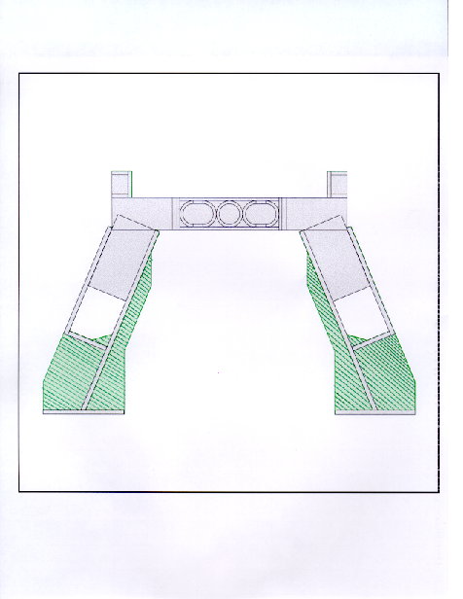

M FEE 2 | FEE Description version
- | ***FOOT PROPER**********Matter Identifier**
9 | Number
-1207.50 -937.50 -662.50 -342.50 | Z_Positions (center of foot)
0.00 342.50 662.50 937.50 | Z_Positions (center of foot)
1207.50 | Z_Positions (center of foot)
12.00 16.00 56.00 35.00 | Thicknesses (EP1, EP2), S_Widths (DSS, DSP)
46.00 36.00 | Small support triangle dimensions (DD1, DD2)
44.00 62.00 64.00 | Half Z_Widths (DZ1, DZ2, DZ3)
660.00 720.00 1200.00 | T_Dimensions of inner iron plate (TI1, TM1, TA1)
700.00 1017.00 870.00 | T_Dim. of outer and lateral plates (TI1, TA2, TA3)
82.00 165.00 | X-Y _Dimensions of top of lateral plates (DL1, DL2)
110.00 110.00 | X_Dimensions of “socle” (DX1, DX2)
54.00 72.00 10.00 | X-Y _Dim. & Thickness of “rail box”(DBX,DBY,DBE)
15.00 -20.00 -10.00 | Last Feet Variations in DZ1/2/3, DL1/-DBY, TA3
- |****BARR BETWEEN TWO FEET***Matter Identifier**
30.00 27.00 8.00 8.00 | Half Z_Widths & Thicknesses (DZ1, DZ2, EP1, EP2)
30.00 27.00 27.00 35.00 | X_Dim. of internal reinforcement (DX1, 2, 3, 4)
18.00 25.00 0.00 | Y_Dim. of int. reinf. (DY1, 2) & hole radius (RTR)

Table 3 : The AMDB description of Feet ( version m2.8)
Figure 4 : View of the Feet. The part not yet implemented part is shown in green (striped pattern).

<?xml version=”1.0” encoding=”iso-8859-1” standalone=”no” ?>
<!DOCTYPE AGDD SYSTEM “AGDD.dtd” [
<!ENTITY Material SYSTEM “Material_AGDD.xml”> ]>
<AGDD DTD_version=”v4”>
<!—----------------------------------------Material definition-------------------------------------------→
&Material;
<!-------------------------------------------Section definition --------------------------------------------→
<section name = “FEE”
version = “1.0”
date = “16 May 2002”
author = “M.Paniccia”
top_volume = “ATLAS”
DTD_version = “v4” >
<!-----------------------------------------Feet definition-------------------------------------------→
<compact name=”FEE_INN_PLATE”>
<FEE_Inner_Plate TI1=”6600.0” TM1=”7200.0” TA1=”12000.0” unit_length=”mm”/>
</compact>
<compact name=”FEE_OUT_PLATE”>
<FEE_Outer_Plate TI2=”7000.0” TA2=”10170.0” unit_length=”mm”/>
</compact>
<compact name=”FEE_LAT_PLATE”>
<FEE_Lateral_Plate T_Dim_TA3=”8700.0” Top_X_Dim=”820.0” Top_Y_Dim=”1650.0”
Triangle_DD1=”460.0” Triangle_DD2=”360.0” unit_length=”mm”/>
</compact>
<compact name=”FEE_SOCLE”>
<FEE_Socle X1_Dim=”1100.0” X2_Dim=”1100.0” unit_length=”mm”/>
</compact>
<compact name=”FEE_RAIL_BOX”>
<FEE_Rail_Box X_Dim=”540.0” Y_Dim=”720.0” Thickness=”100.0” unit_length=”mm”/>
</compact>
<compact name=”FEE_BARR_IR”>
<FEE_Barr_IntReinf Half_Z_Width_DZ2=”270.0” Thickness_EP2=”80.0”
Int_Reinf_DX1=”300.0” Int_Reinf_DX2=”300.0”
Int_Reinf_DX3=”270.0” Int_Reinf_DX4=”350.0”
Int_Reinf_DY1=”180.0” Int_Reinf_DY2=”250.0” unit_length=”mm”/>
</compact>
<compact name=”FEE_BARR”>
<FEE_Barr Half_Z_Width_DZ1=”270.0” Thickness_EP1=”80.0” Hole_rad=”0.0”
Int_Reinf_Desc=”FEE_BARR_IR” unit_length=”mm”/>
</compact>
<compact name=”FEE_LAST_VAR”>
<FEE_Last_Var Var_DZ1=”150.0” Var_DZ2=”150.0” Var_DZ3=”150.0”
Var_Dl1=”-200.0” Var_DBY=”200.0” Var_TA3=”-100.0” unit_length=”mm”/>
</compact>
<compact name=”FEE_POS”>
<FEE_z_list Number=”9” z1=”-12070.0” z2=”-9375.0” z3=”-6625.0” z4=”-3425.0” z5=”0.”
z6=”3425.0” z7=”6625.0” z8=”9375.0” z9=”12070.0”unit_length=”mm”/>
</compact>
<compact name=”FEE”>
<FEE Thickness _EP1=”120.0” Thickness _EP2=”160.0” S_Width_DSS=”560.0”S_Width_DSP=”350.0”
Half_Z_Width_DZ1=”440.0” Half_Z_Width_DZ2=”620.0” Half_Z_Width_DZ3=”640.0”
Inner_Plate_Desc=”FEE_INN_PLATE” Outer_Plate_Desc=”FEE_OUT_PLATE”
Lat_Plate_Desc=”FEE_LAT_PLATE” Socle_Desc=”FEE_SOCLE”
Rail_Box_Desc=”FEE_RAIL_BOX” Barr_Desc=”FEE_BARR”
Last_Feet_Var=”FEE_LAST_VAR” Feet_Position=”FEE_POS”
unit_length=”mm” />
</compact>
<!----------------------------Positioning all Feet in ATLAS--------------------------→
< composition name=”ATLAS”>
<posXYZ volume=”FEE” />
</composition>
</section>
</AGDD>
Table 4 : XML description of Feet

As with the Endcap Toroids, an effort has been made in the description of the Feet (table 4) to maintain the same data structure as in the AMDB database (table 3). Again, C++ classes have been defined for each compact element ( FEE_Barr, FEE_Barr_IntReinf, FEE_Inner_Plate, FEE_Lateral_Plate, FEE_Socle, FEE_Rail_Box, FEE_Last_Var, FEE_z_list , FEE). Due to the variation of the dimensions in the outermost feet, the code development for the expand() method has been more delicate than in the previous case. Furthermore the responsibility of positioning the nine feet has been given to the main class ( FEE ), which returns automatically all the feet already positioned in the ATLAS detector system of reference.

2.3 ATLAS Magnet System plus Feet

Since similar work has been done for the Barrel Toroid, the necessary code to obtain in one file the description of all the main inert material embedded in the ATLAS Muon Spectrometer becomes a very straightforward task: build a unique XML file chaining BAR.xml, ENC.xml and FEE.xml. Figure 5 shows the result.
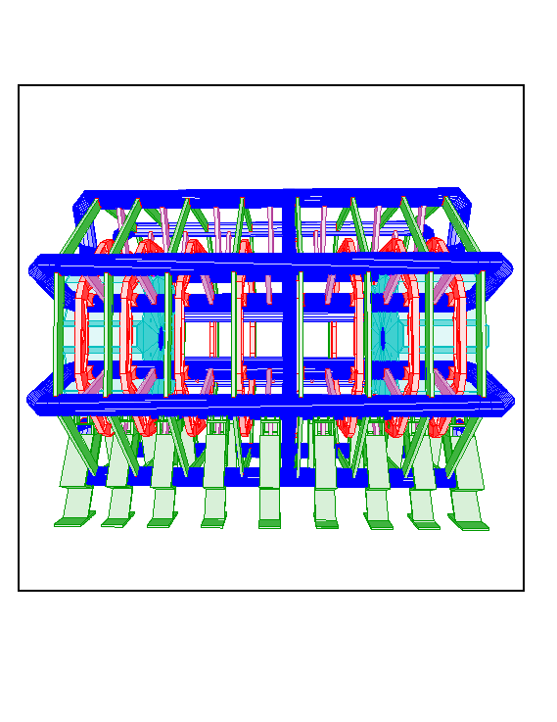
Figure 5 : ATLAS Barrel Toroid , Endcap Toroids and Feet
3. Conclusions

So far we have described in AGDD most of the inert material embedded in the ATLAS Muon Spectrometer for the geometry layout m2.8; as concern the subsequent layout p.03, a few more structures need to be added: in particular a “service turret” to the Endcap Toroids [15], and a “bridge” connecting the adjacent feet.
This work is part of the AGDD development process and of its evaluation as a candidate for the ATLAS detector description database.

References

- http://www.cern.ch/Atlas/GROUPS/MUON/muon_page.html
- http://www.cern.ch/Atlas/GROUPS/MUON/AMDB_SIMREC/amdb_simrec.html
- http://www.cern.ch/Atlas/GROUPS/DATABASE/detector_description/
- http://www.cern.ch/muondoc/software/Database/ ATL-MUON-2001-015: Detector Description Planning Document, by S. Goldfarb
- http://www.cern.ch/Atlas/GROUPS/PHYSICS/TDR/access.html
- http://www.cern.ch/Atlas/GROUPS/MUON/Reconstruction/Muonbox.html
- http://www.cern.ch/Atlas/GROUPS/MUON/ams/muonsimulation/geant3.html
- http://www.cern.ch/Atlas/GROUPS/MUON/persint.html
- http://www.usatlas.bnl.gov/computing/software/moore/
- http://www.cern.ch/Atlas/GROUPS/MUON/ams/muonsimulation/geant4.html
- http://www.cern.ch/Atlas/GROUPS/SOFTWARE/OO/domains/simulation/
- http://www.w3.org/XML/
- http://www.cern.ch/Atlas/GROUPS/DATABASE/detector_description/Doc/main.html
- http://www.cern.ch/muondoc/software/Database/ A Guide to Creating Compact Syntaxes in AGDD, by J. Giansiracusa
- http://www.cern.ch/muondoc/software/Database/DetectorDescription/ Documentation of Endcap Toroid Description, by M. Paniccia

